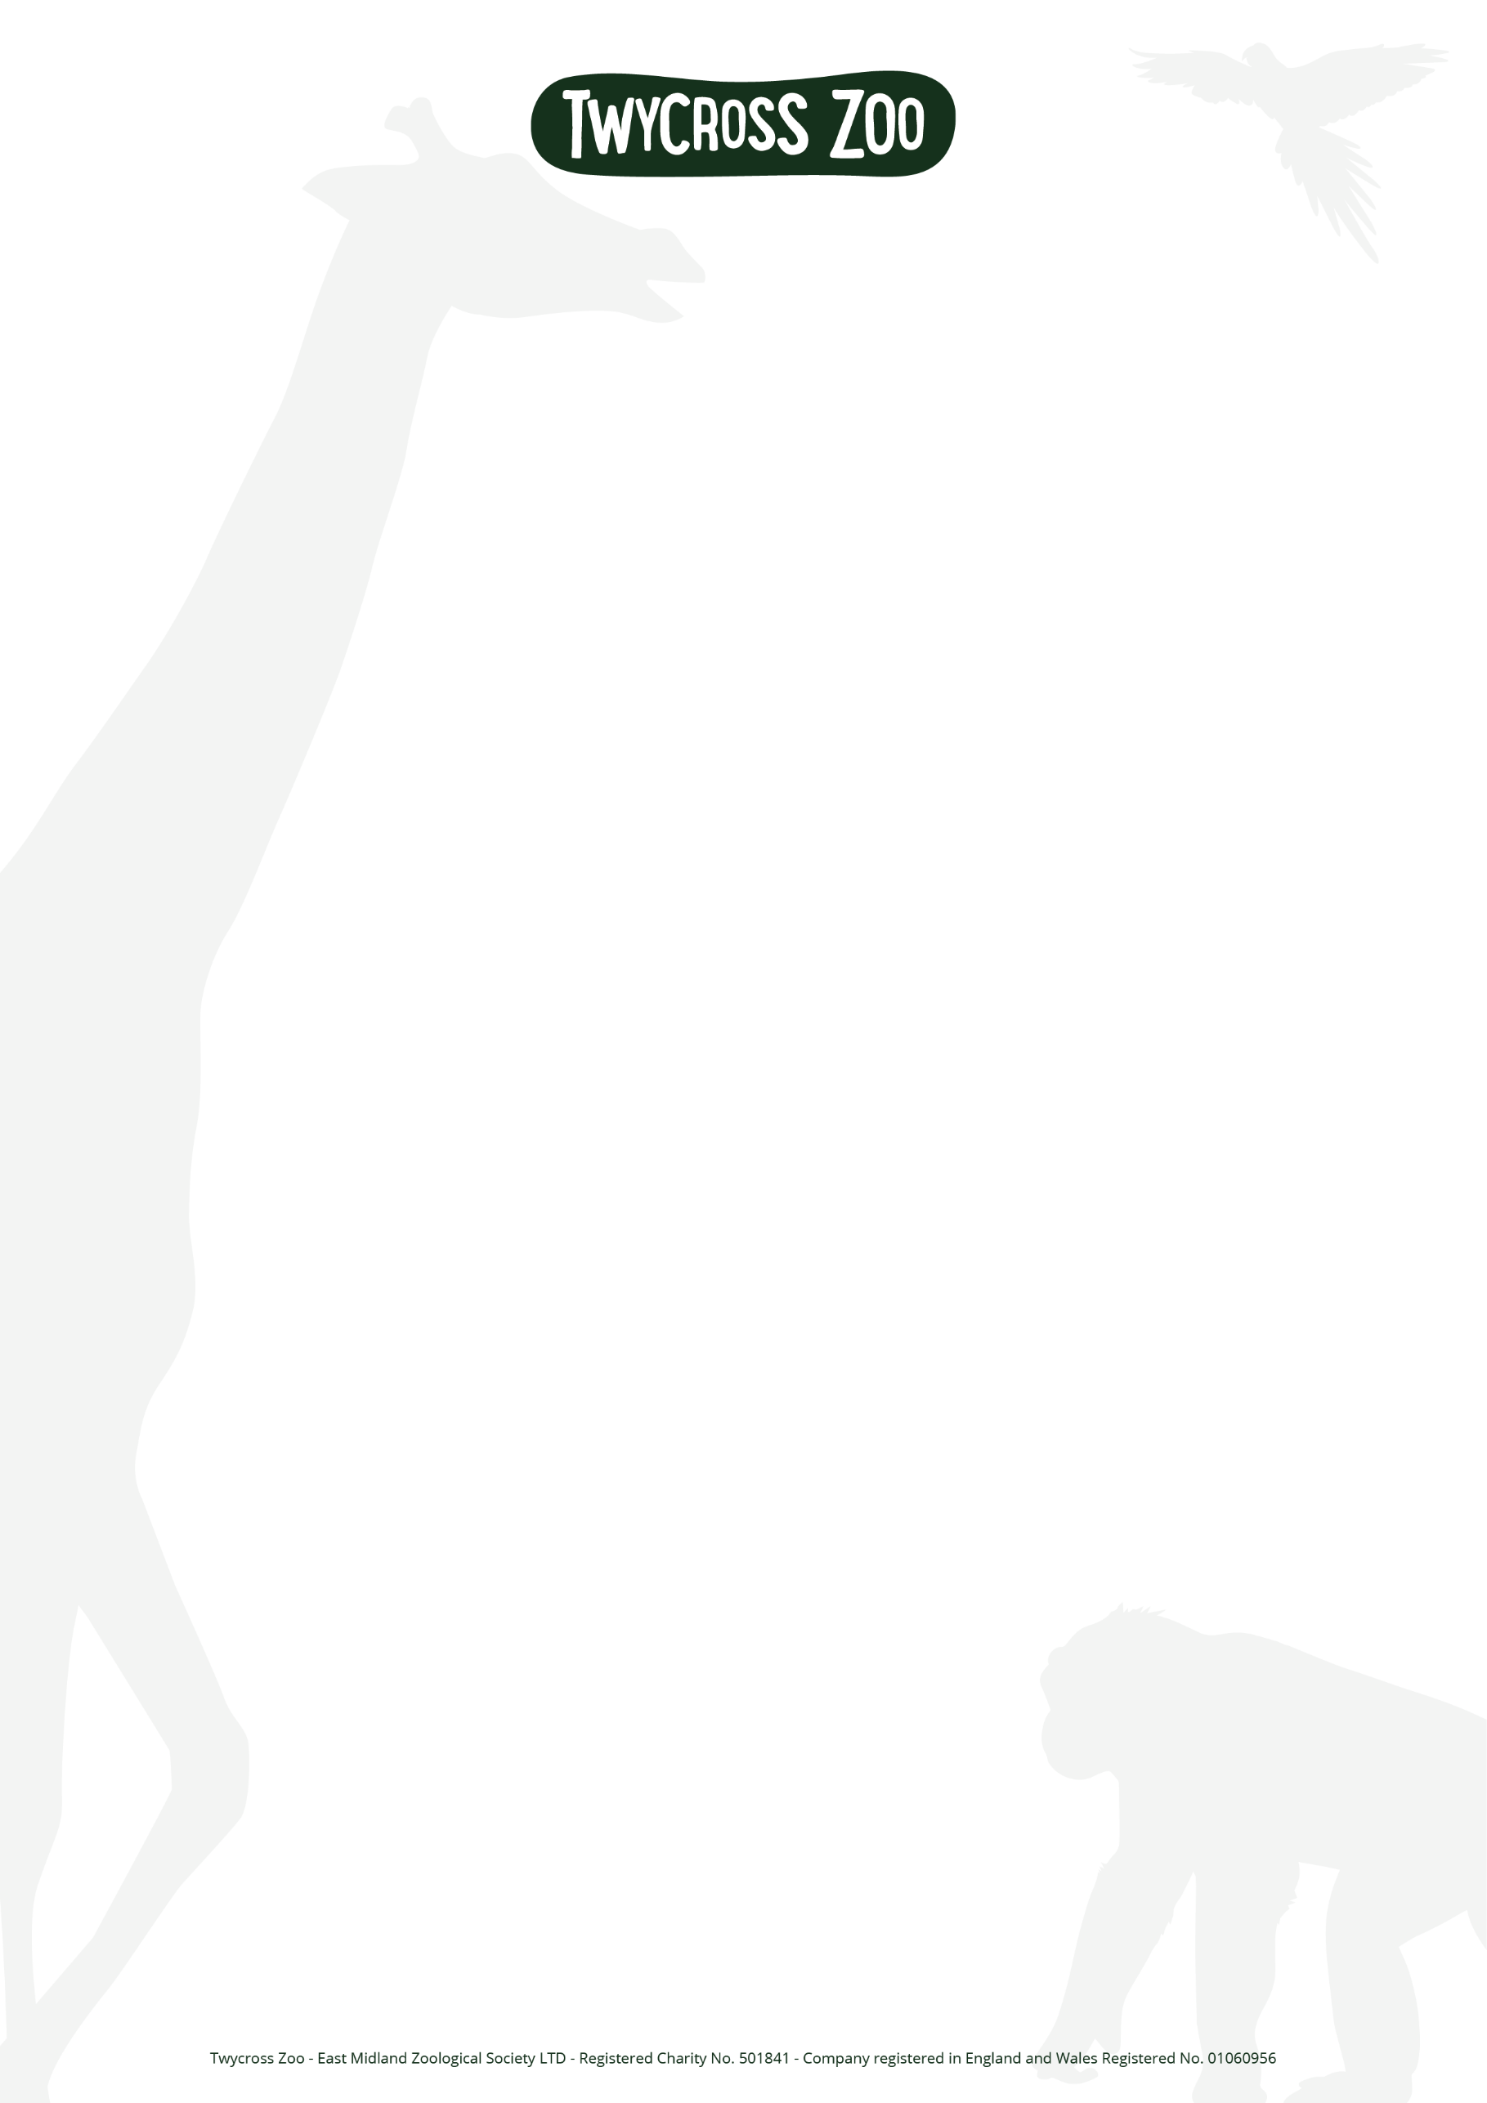
Animal Keeper Mammals (12 month contract)

Salary: £25,956 per annum
Location: Twycross Zoo, Leicestershire
Contract Type: Fixed Term Contract for 12 months (May 2026 to May 2027), Full-time, 5 days out of 7 (37.5 hours/week)

Company Details
At Twycross Zoo, caring for animals is at the heart of everything we do. As a conservation charity, we’re dedicated to protecting endangered species and inspiring people to value the natural world and our Mammals team plays a vital role in that mission every day. This is an exciting moment to join us. With the Global Conservation Centre opening in 2026 and major projects continuing to draw new audiences, our work behind the scenes is more important than ever. Our Mammals section is home to an incredible range of species, from large hoofstock and carnivores to smaller mammals including giraffes, rhinos, tigers, snow leopards, meerkats, capybara, goats and more. The care, knowledge and skill of our keepers directly supports their welfare, breeding programmes and long-term conservation.

The Role – Animal Keeper

As an Animal Keeper, you’ll play a key role in caring for the animals in our mammals section, which includes the large and small hoofstock, carnivores and small mammals (for example: Giraffes, Rhinos, Meerkats, Tigers, Snow Leopard, Goats, Capybara). You will help to ensure that animal keeping is carried out to the Zoo’s required standards, with duties that will include although not be limited to:
- Preparing and distributing food and water to animals
- Learning about the animals and reporting any animal health concerns to the Team Leader
- Assisting with maintaining enclosures and public viewing areas ensuring a high standard of hygiene, cleanliness and exhibition
- Answering enquiries from the public in a helpful and polite manner, delivering encounters and assisting with visitor events

Our Requirements - Animal Keeper
- Experience as an Animal Keeper in a zoo environment, which must have included working with category one mammals
- Superb knowledge of animals that will be within your regular care and all responsible work practices relevant to zoonotic diseases
- A passion for Twycross Zoo’s work and purpose
- Self-motivated and with ability to work independently and as part of a team
- A flexible approach to duties and working hours
- Whilst we are an equal opportunities employer, you will need to be physically fit due to the nature and demands of the role

Although not essential, an appropriate animal related qualification would be highly advantageous.

Working on average 5 days out of 7 on a three-week rolling rota between the hours of 8am to 5pm during the summer and 8am to 4pm during the winter months.
Benefits
Benefits

Just some of the benefits include;
- 31 days annual leave, including bank holidays
- Life assurance
- Company sick pay from day one of absence, once successfully completed probation period
- Access to discount platform
- Staff membership card giving you free entry to the zoo on your days off
- Complimentary Twycross Zoo ticket allowance for friends and family
- Discount in the Twycross Zoo gift shop
- Discount in Twycross Zoo food and beverage outlets
- Monthly recognition award scheme
- Access to employee assistance services
- Free parking

How to Apply
Please submit your CV and a covering letter to human.resources@twycrosszoo.org. Applications will be reviewed and the vacancy will close once the role is filled.

